Hackathon Project Phases Template that ensures students can complete it efficiently while covering all six phases. The template is structured to capture essential information without being time-consuming.

Hackathon Project Phases Template

Project Title:
AI-Powered Ethical Decision Making Simulations with Mistral

Team Name: VALORANT

Team Members:
- P.SRUJAN SINHA
- T.VENKATA TEJ KUMAR
- P.PAVAN KUMAR
- P.RISHI MADHAVAN

Phase-1: Brainstorming & Ideation

Objective:
- Ethical decision-making is a critical skill in various fields, from policy-making to business management. However, exploring complex ethical scenarios and their potential outcomes can be challenging and time-consuming. The Ethical Decision-Making Simulations application, powered by Mistral's AI, addresses these challenges by providing a tool that generates detailed ethical scenarios and potential consequences based on user-provided policy questions. This application aims to enhance understanding of ethical implications and foster more informed decision-making processes.

Key Points:
- Problem Statement: Ethical decision-making is a critical skill in various fields, from policy-making to business management. However, exploring complex ethical scenarios and their potential outcomes can be challenging and time-consuming. The Ethical Decision-Making Simulations application, powered by Mistral's AI, addresses these challenges by providing a tool that generates detailed ethical scenarios and potential consequences based on user-provided policy questions. This application aims to enhance understanding of ethical implications and foster more informed decision-making processes.
- Proposed Solution: This comprehensive solution ensures that the AI-powered ethical decision-making simulation application is effectively designed, developed, and deployed, with a focus on achieving the desired objectives and providing valuable insights to users.
- Target Users: The target users for AI-powered ethical decision-making simulations can vary widely, but typically include professionals and organizations in fields where ethical dilemmas are common. Here are some key groups:

- Policymakers
- Business Leaders
- Healthcare Professionals
- Educators and Students
- Legal Professionals
- Nonprofit Organizations
- Tech Industry Professionals
- Corporate Ethics Officers

These target users benefit from simulations that help them navigate complex ethical landscapes, enhance their decision-making capabilities, and foster a culture of integrity and responsibility.
- Expected Outcome: The expected outcomes from using AI-powered ethical decision-making simulations are multifaceted and highly beneficial. Overall, AI-powered ethical decision-making simulations aim to cultivate a more ethically aware, skilled, and responsible society, both in individual and organizational contexts.

Phase-2: Requirement Analysis

Objective:
The functional requirements involve creating an intuitive user interface with interactive ethical scenarios, personalized user profiles, and adaptive learning capabilities. The simulation engine should generate diverse ethical dilemmas, track user decisions, and analyze outcomes to provide detailed feedback. The platform must include reporting and analytics features to visualize user progress and calculate an ethical score, ensuring data protection through end-to-end encryption, role-based access control, and compliance with regulations like GDPR and CCPA, while adhering to ethical AI standards.

Key Points:
- Technical Requirements:
Languages:
- Python: AI model and backend
- JavaScript: Frontend
Frameworks:
- TensorFlow/ PyTorch: AI model
- Flask/Django: Backend
- React.js: Frontend
Tools:
- Docker: Containerization
- AWS/Azure: Cloud services
- PostgreSQL: Database
- Git/GitHub: Version control

- Functional Requirements:

- Interactive Scenarios: Users engage with ethical dilemmas.
- User Profiles: Personalized experiences.
- Decision Tracking: Monitor user choices and paths.
- Outcome Analysis: Detailed feedback on decisions.
- Reporting: Progress and ethical score reports.
- Security: Data protection and compliance with regulations.

- Constraints & Challenges:
• Data Privacy: Ensuring user data is protected and compliant with regulations.
• Complexity: Balancing detailed scenarios with simplicity for user engagement.
• Bias Mitigation: Addressing potential biases in AI-generated decisions.
• Scalability: Handling increasing user load without performance degradation.
• Ethical Standards: Maintaining high ethical standards in AI decision-making.

Phase-3: Project Design

Objective:
Architecture:
- Frontend:
  - React.js for user interface.
  - HTML, CSS, JavaScript for responsive design.
- Backend:
  - Flask/Django for handling API requests.
  - TensorFlow/PyTorch for AI model implementation.
  - PostgreSQL for database management.
- Deployment:
  - AWS/Azure for cloud services.
  - Docker for containerization.
  - Jenkins/GitHub Actions for CI/CD.
User Flow:
- User Registration/Login:
  - User signs up or logs in.
- Dashboard:
  - User navigates the main dashboard.
- Simulation Selection:
  - User selects an ethical dilemma.
- Interactive Scenario:
  - User interacts with the scenario, making decisions.
- Outcome Analysis:
  - System provides feedback and analysis.
- Progress Tracking:
  - User views progress and ethical score on the dashboard.

Key Points:
- System Architecture Diagram: 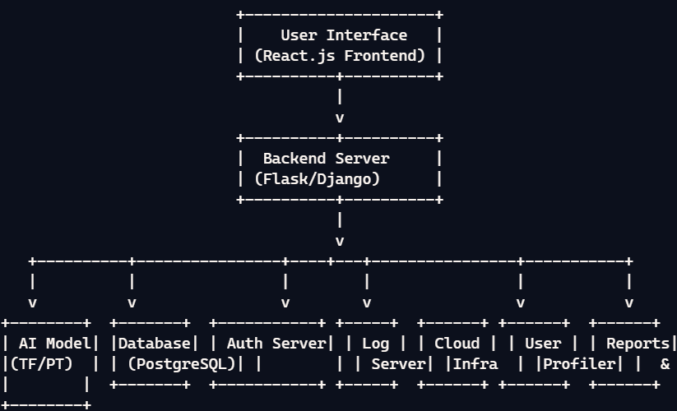
- User Flow:
- Registration/Login:
  - User signs up with basic details or logs in with existing credentials.
- Dashboard:
  - User lands on the dashboard, which displays available simulations and their progress.
- Simulation Selection:
  - User browses through a list of ethical dilemmas and selects one to engage with.
- Interactive Scenario:
  - User is presented with the scenario and makes decisions at various key points.
  - The system provides real-time feedback based on the decisions made.
- Outcome Analysis:
  - After completing the scenario, the system analyzes the user's decisions and presents the outcomes.
  - Detailed feedback and insights are provided to help the user understand the ethical implications of their choices.
- Progress Tracking:
  - User can view their progress, ethical scores, and historical decisions on their profile.
  - Reports and visualizations help track improvement and learning over time.
- Logout:
  - User logs out securely when done.

- UI/UX Considerations:
Wireframe Layout:
Dashboard:
  - Header: Logo, navigation links (Home, Simulations, Profile), user profile icon.
  - Main Section:
    - Sidebar: List of available simulations with brief descriptions.
    - Content Area: Current simulation details, progress overview, and start button.
Simulation Screen:
  - Header: Scenario title, progress bar.
  - Main Section:
    - Scenario Description: Detailed ethical dilemma description.
    - Decision Points: Multiple-choice options for user decisions.
    - Feedback Section: Real-time feedback based on user choices.
  - Footer: Navigation buttons (Previous, Next).
Outcome Analysis:
  - Header: Analysis title.
  - Main Section:
    - Summary: Summary of user decisions.
    - Detailed Analysis: Feedback and ethical implications.
  - Footer: Option to return to dashboard or retry the simulation.
Profile Page:
  - Header: User profile info.
  - Main Section:
    - Progress Overview: User's progress and ethical score.
    - Reports and Analytics: Visualizations of decision patterns and trends.
  - Footer: Logout button.
UX Considerations:
  - Intuitive Navigation: Ensure users can easily find and access simulations, their progress, and reports.
  - Responsive Design: Optimize for both desktop and mobile devices.
  - Clear Feedback: Provide clear and actionable feedback on decisions.
  - Accessibility: Ensure the interface is accessible to users with disabilities (e.g., screen reader compatibility, keyboard navigation).
  - Consistent Design: Use consistent color schemes, fonts, and layout throughout the application for a cohesive look and feel.
This approach ensures a user-friendly and engaging interface for the AI-powered ethical decision-making simulations.

Phase-4: Project Planning (Agile Methodologies)
Objective:
To develop an AI-powered ethical decision-making simulation using Mistral that facilitates interactive and engaging scenarios. The system will enable users to explore and understand the implications of their ethical choices through real-time feedback and detailed outcome analysis. The project aims to ensure data protection, compliance with regulations, and adherence to ethical AI standards, while providing a seamless and personalized user experience. By using Agile methodologies, the project will be developed iteratively with continuous improvements and feedback integration.

Key Points:
- Sprint Planning:
- Sprint 1: User Authentication
Frontend Developer
Backend Developer
Sprint 2: Scenario Engine
Frontend Developer
Backend Developer
Sprint 3: Outcome Analysis
Frontend Developer
Backend Developer
- Task Allocation: team leader
- Timeline & Milestones: (Set short deadlines for each task)

Phase-5: Project Development

Objective:
1. Frontend:
- Develop user interface using React.js.
- Implement scenario presentation and user interaction.
2. Backend:
- Set up Flask/Django project.
- Create API endpoints for user authentication, scenario retrieval, and outcome analysis.
3. AI Model:
- Build and train the model using TensorFlow/PyTorch.
- Integrate the model with the backend for real-time feedback.
4. Database:
- Set up PostgreSQL database.
- Store user data, scenarios, and outcomes.
5. Deployment:
- Containerize the application using Docker.
- Deploy on cloud services like AWS or Azure.
- Set up CI/CD pipeline for automated testing and deployment.

Key Points:
- Technology Stack Used:
- Programming Languages: Python, JavaScript
- Frontend: React.js
- Backend: Flask/Django
- AI Model: TensorFlow/PyTorch
- Database: PostgreSQL
- APIs: RESTful APIs
- Deployment: Docker, AWS/Azure
- CI/CD: Jenkins/GitHub Actions

  - Development Process:
• Requirements Gathering: Define technical and functional requirements.
• Setup Environment: Set up development environment and tools.
• Frontend Development: Create UI components and pages using React.js.
• Backend Development: Implement APIs and server-side logic with Flask/Django.
• AI Model Integration: Build, train, and integrate the AI model using TensorFlow/PyTorch.
• Database Setup: Configure PostgreSQL and manage data storage.
• Testing: Conduct unit and integration testing.
• Deployment: Containerize using Docker and deploy on AWS/Azure.
• CI/CD: Implement continuous integration and deployment pipelines with Jenkins/GitHub Actions.
• Monitoring: Set up monitoring and logging.

  - Challenges & Fixes: (Mention any obstacles faced and how they were solved)

- Data Privacy:
  - Challenge: Ensuring compliance with GDPR and CCPA.
  - Fix: Implemented end-to-end encryption and role-based access control.
- Bias Mitigation:
  - Challenge: Addressing potential biases in AI model decisions.
  - Fix: Trained the model with diverse and balanced datasets, and conducted regular bias audits.
- Scalability:
  - Challenge: Handling increasing user load without performance issues.
  - Fix: Deployed the application using Kubernetes for scalable container orchestration.
- Complexity:
  - Challenge: Balancing detailed scenarios with user-friendly design.
  - Fix: Iteratively tested and refined scenarios with user feedback.
- Security:
  - Challenge: Protecting sensitive user data.
  - Fix: Regularly updated security protocols and conducted penetration testing.

Phase-6: Functional & Performance Testing

Objective:
  - Ensure the project works as expected.

Key Points:
- Test Cases Executed: (List the scenarios tested)
- Bug Fixes & Improvements: (Mention fixes made)
- Final Validation: (Does the project meet the initial requirements?)
- Deployment (if applicable): (Hosting details or final demo link)

Final Submission
- Project Report Based on the templates
- Demo Video (3-5 Minutes)
- GitHub/Code Repository Link
- Presentation

